

**TITLE OF THESIS**

**NAME**

**DOCTOR OF PHILOSOPHY / MASTER**

**UNIVERSITI PUTRA MALAYSIA**

**2016**



**TITLE OF THESIS**

By

**YOUR NAME IN ALL CAPITAL LETTERS**

Thesis Submitted to the School of Graduate Studies, Universiti Putra Malaysia, in Fulfilment of the Requirement of The Degree of **Name of degree**

**MONTH 2016**

**COPYRIGHT**

All material contained within the thesis, including without limitation text, logos, icons, photographs and all other artwork, is copyright material of Universiti Putra Malaysia unless otherwise stated. Use may be made of any material contained within the thesis for non-commercial purposes from the copyright holder. Commercial use of material may only be made with the express, prior, written permission of Universiti Putra Malaysia.

Copyright © Universiti Putra Malaysia

ABSTRACT

Abstract of thesis presented to the Senate of Universiti Putra Malaysia in fulfilment of the requirement for the degree of (name of degree)

**TITLE OF THESIS**

By

**NAME OF STUDENT**

**Month and Year of Viva Voce**

**Chair: Name of Chairman of Supervisory Committee, PhD**

**Faculty: Name of Faculty**

The abstract is a digest of the entire thesis and should be given the same consideration as the main text. It does not normally include any reference to the

literature. Abbreviations or acronyms must be preceded by the full term at the

first use.

An abstract should be between 300-500 words. It includes a brief statement of the

problem, a concise description of the research method and design, a summary of major findings, including their significance or lack of it, and conclusions.

ABSTRAK

Abstrak tesis yang dikemukakan kepada Senat Universiti Putra Malaysia

Sebagai memenuhi keperluan untuk ijazah (nama ijazah)

**TAJUK TESIS**

Oleh

**NAMA CALON**

**Bulan dan Tahun *Viva Voce* diadakan**

**Pengerusi: Nama Pengerusi Jawatankuasa Penyeliaan, PhD**

**Fakulti: Nama Fakulti**

Abstrak merupakan ringkasan keseluruhan tesis dan wajib diberi perhatian rapi sepertimana bahagian tesis yang lain. Abstrak tidak mengandungi bahan rujukan. Nama singkatan atau akronim mesti didahului dengan terminology penuh pada penggunaan kali pertama.

Abstrak harus diolah antara 300-500 perkataan. Abstrak merangkumi peryataan permasalahan, penerangan rigkas dan tepat tentang reka bentuk dan pengkaedahan penyelidikan, rumusan penemuan utama dan kesimpulan.

ACKNOWLEDGEMENTS

First of all, I would like to thank . . . .

APPROVAL

I certify that a Thesis Examination Committee has met on (date of viva voce) to conduct the final examination of (student's name) on his (or her) thesis entitled (“Title of Thesis”) in accordance with the Universities and University Colleges Act 1971 and the Constitution of the Universiti Putra Malaysia [P.U.(A) 106] 15 March 1998. The Committee recommends that the student be awarded the (insert the name of relevant degree).

Members of the Thesis Examination Committee were as follows:

**Name of Chairperson, PhD**

Title (e.g., Professor/Associate Professor/Ir; omit if irrelevant)

Name of Faculty

Universiti Putra Malaysia

(Chairman)

**Name of Examiner 1, PhD**

Title (e.g., Professor/Associate Professor/Ir; omit if irrelevant)

Name of Faculty

Universiti Putra Malaysia

(Internal Examiner)

**Name of Examiner 2, PhD**

Title (e.g., Professor/Associate Professor/Ir; omit if irrelevant)

Name of Faculty

Universiti Putra Malaysia

(Internal Examiner)

**Name of External Examiner, PhD**

Title (e.g., Professor/Associate Professor/Ir; omit if irrelevant)

Name of Department and/or Faculty

Name of Organisation (University/Institute)

Country

(External Examiner)

**_________________________________**

**(Insert name of current Deputy Dean)**

**(E.g. XXXX XXXX, PhD)**

Deputy Dean

School of Graduate Studies

Universiti Putra Malaysia

Date:

This thesis was submitted to the Senate of Universiti Putra Malaysia and has been accepted as fulfilment of the requirement for the degree of ………… (type of degree). The members of the Supervisory Committee were as follows:

**Name of Chairperson, PhD (omit `PhD’ if not applicable)**

Title (e.g., Professor/Associate Professor/Ir; if applicable)

Name of Faculty

Universiti Putra Malaysia

(Chairman)

**Name of Member 1, PhD (omit `PhD’ if not applicable)**

Title (e.g., Professor/Associate Professor/Ir; if applicable)

Name of Faculty

Universiti Putra Malaysia

(Member)

**Name of Member 2, PhD (omit `PhD’ if not applicable)**

Title (e.g., Professor/Associate Professor/Ir; if applicable)

Name of Department and/or Faculty

Name of Organisation (University / Institute)

(Member)

________________________

**(Insert name of current Dean)**

**(E.g. XXXXX XXXX, PhD)**

Professor and Dean

School of Graduate Studies

Universiti Putra Malaysia

DECLARATION

**Declaration by graduate student**

I hereby confirm that:

* this thesis is my original work;
* quotations, illustrations and citations have been duly referenced;
* this thesis has not been submitted previously or concurrently for any other degree at any other institutions;
* intellectual property from the thesis and copyright of thesis are fully-owned by Universiti Putra Malaysia, as according to the Universiti Putra Malaysia (Research) Rules 2012;
* written permission must be obtained from supervisor and the office of Deputy Vice-Chancellor (Research and Innovation) before thesis is published (in the form of written, printed or in electronic form) including books, journals, modules, proceedings, popular writings, seminar papers, manuscripts, posters, reports, lecture notes, learning modules or any other materials as stated in the Universiti Putra Malaysia (Research) Rules 2012;
* there is no plagiarism or data falsification/fabrication in the thesis, and scholarly integrity is upheld as according to the Universiti Putra Malaysia (Graduate Studies) Rules 2003 (Revision 2012-2013) and the Universiti Putra Malaysia (Research) Rules 2012. The thesis has undergone plagiarism detection software.

Signature: ________________________ Date: __________________

Name and Matric No.: _________________________________________

**Declaration by Members of Supervisory Committee**

This is to confirm that:

* the research conducted and the writing of this thesis was under our supervision;
* supervision responsibilities as stated in the Universiti Putra Malaysia (Graduate Studies) Rules 2003 (Revision 2012-2013) are adhered to.

|  |  |  |
| --- | --- | --- |
| Signature: |  |  |
| Name of Chairman of Supervisory Committee: |  |  |
| Signature: |  |  |
| Name of Member of Supervisory Committee: |  |  |

|  |  |  |
| --- | --- | --- |
| Signature: |  |  |
| Name of Member of Supervisory Committee: |  |  |

|  |  |  |
| --- | --- | --- |
| Signature: |  |  |
| Name of Member of Supervisory Committee: |  |  |

TABLE OF CONTENTS

ABSTRACT ii

ABSTRAK iii

ACKNOWLEDGEMENTS iv

APPROVAL v

DECLARATION vii

TABLE OF CONTENTS ix

LIST OF TABLES xiii

LIST OF FIGURE xiv

LIST OF ABBREVIATIONS xv

CHAPTER 1 INTRODUCTION 1

1.1 Penang Industrial Area 1

1.2 Prai Industrial Area 1

1.3 Example Caption For Table 2

1.4 Example Caption for Figure 3

1.5 Characteristic and Analysis of Industrial Wastewater 4

1.6 Simulation of Industrial Wastewater 4

1.7 Wastewater Treatment 4

1.7.1 Physico-Chemical Treatment of Mixed Effluent 4

1.7.2 Biological Treatment 4

1.8 Microspopic and Inhibition Study 4

1.9 Objective of Study 4

CHAPTER 2 LITERATURE REVIEW 5

2.1 Literature Review 5

2.2 Sources of Particulate Matter 7

2.2.1 Motor Vehicles 7

2.2.2 Industry / Power Plants 7

2.2.3 Open Burning / Trans-Boundary 7

2.2.4 Characteristics of Particulate Matter 7

2.2.5 Effect of Pm10 on Humans 7

2.2.6 Weather Influence 7

2.3 Wind Speed 7

2.4 Temperature and Sunlight 7

2.5 Relative Humidity 7

2.6 Regression Models 7

2.6.1 Multiple Linear Regressions 7

2.6.2 Robust Regression 7

2.6.3 Quantile Regression 7

2.7 Hybrid Model 7

2.7.1 Principal Component Analysis 7

2.8 Conclusion 7

CHAPTER 3 METHODOLOGY 8

3.1 Introduction 8

3.2 Study Area 8

3.3 Monitoring Record Acquisitions 8

3.4 Parameters Selection 8

3.5 Monitoring Record Screening 8

3.6 Descriptive Statistics 8

3.6.1 Box and Whisker Plot 8

3.6.2 One Way Analyses of Variance 8

3.7 Monitoring Record Management 9

3.8 Regression Models 9

3.8.1 Multiple Linear Regression Models 9

3.8.2 Robust Regression Models 9

3.8.3 Quantile Regression Models 9

3.9 Artificial Neural Network Models 9

3.9.1 Feedforward Models 9

3.9.2 General Regression Neural Network 9

3.10 Principal Component Analysis 9

CHAPTER 4 RESULTS AND FINDINGS 10

4.1 Introduction 10

4.2 Characteristic of Monitoring Record 10

4.2.1 Descriptive Statistics 10

4.2.2 Box and Whisker Plot 10

4.2.3 One Way Analyses of Variance (ANOVA) 10

4.3 Regression Models 10

4.3.1 Multiple Linear Regression Model 10

4.3.2 Robust Regression Models 10

4.3.3 Quantile Regression Models 10

4.4 Artificial Neural Network Model 10

4.4.1 Feedforward Backpropagation Models 10

4.4.2 General Regression Neural Network Models 10

4.5 Application of Hybrid Models 10

4.5.1 Principal Component Analysis 10

4.5.2 Principal Component Analysis and Multiple Linear Regressions 10

4.5.3 Principal Component Analysis and Robust Regression 10

4.6 Verification of Models 11

4.7 Determining the Most Suitable Model 11

4.8 Developing a New Predictive Tool for Future PM10 11

4.9 Concentrations Prediction in Malaysia 11

CHAPTER 5 DISCUSSION 12

5.1 Introduction 12

5.2 Regression Models 12

5.3 Artificial Neural Network Models 12

5.4 Hybrid Models 12

5.5 The Most Suitable Model 12

CHAPTER 6 SUMMARY AND CONCLUSIONS 13

6.1 Conclusion 13

6.2 Limitation and Future Work 13

REFERENCES 14

APPENDICES 15

APPENDIX A 16

APPENDIX B 17

BIODATA OF STUDENT 18

LIST OF PUBLICATIONS 19

LIST OF TABLES

Table 1.1 : Table caption 2

Table 2.1 : Type Your Caption Here 5

LIST OF FIGURE

Figure 1.1 : Caption Figure 3

Figure 2.1 : Type Your Caption Here 4

Figure 2.2 : Type Your Caption Here 4

LIST OF ABBREVIATIONS

|  |  |
| --- | --- |
| **Symbols** |  |
|  |  |
|  |  |
|  |  |
|  |  |
|  |  |
|  |  |
|  |  |

*Sort symbols according to alphabetical highlight table above and select no border to remove border line.*

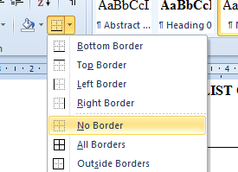

# INTRODUCTION

## Penang Industrial Area

On the Insert tab, the galleries include items that are designed to coordinate with the overall look of your document. You can use these galleries to insert tables, headers, footers, lists, cover pages, and other document building blocks. When you create pictures, charts, or diagrams, they also coordinate with your current document look.

You can easily change the formatting of selected text in the document text by choosing a look for the selected text from the Quick Styles gallery on the Home tab. You can also format text directly by using the other controls on the Home tab. Most controls offer a choice of using the look from the current theme or using a format that you specify directly.

To change the overall look of your document, choose new Theme elements on the Page Layout tab. To change the looks available in the Quick Style gallery, use the Change Current Quick Style Set command. Both the Themes gallery and the Quick Styles gallery provide reset commands so that you can always restore the look of your document to the original contained in your current template.

## Prai Industrial Area

On the Insert tab, the galleries include items that are designed to coordinate with the overall look of your document. You can use these galleries to insert tables, headers, footers, lists, cover pages, and other document building blocks. When you create pictures, charts, or diagrams, they also coordinate with your current document look.

You can easily change the formatting of selected text in the document text by choosing a look for the selected text from the Quick Styles gallery on the Home tab. You can also format text directly by using the other controls on the Home tab. Most controls offer a choice of using the look from the current theme or using a format that you specify directly.

To change the overall look of your document, choose new Theme elements on the Page Layout tab. To change the looks available in the Quick Style gallery, use the Change Current Quick Style Set command. Both the Themes gallery and the Quick Styles gallery provide reset commands so that you can always restore the look of your document to the original contained in your current template.

## Example Caption For Table

Table 1.1 : Table caption

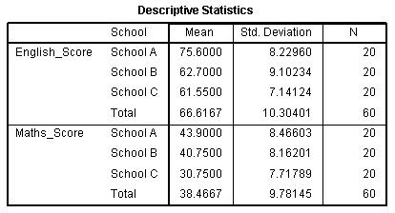

## Example Caption for Figure

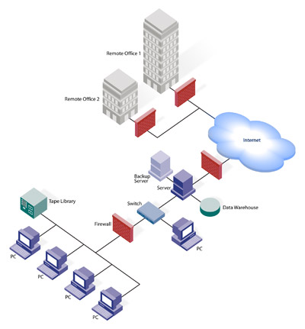

Figure 1.1 : Caption Figure

## Characteristic and Analysis of Industrial Wastewater

## Simulation of Industrial Wastewater

## Wastewater Treatment

### Physico-Chemical Treatment of Mixed Effluent

### Biological Treatment

## Microspopic and Inhibition Study

## Objective of Study

# LITERATURE REVIEW

## Literature Review

On the Insert tab, the galleries include items that are designed to coordinate with the overall look of your document. You can use these galleries to insert tables, headers, footers, lists, cover pages, and other document building blocks. When you create pictures, charts, or diagrams, they also coordinate with your current document look.

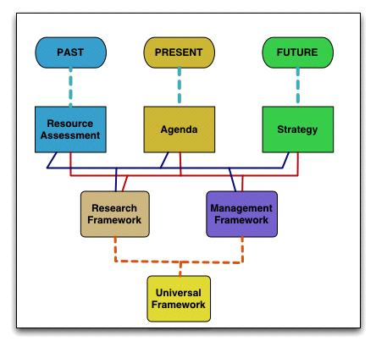

Figure 2.1 : Type Your Caption Here

Figure 2.2 : Type Your Caption Here

You can easily change the formatting of selected text in the document text by choosing a look for the selected text from the Quick Styles gallery on the Home tab. You can also format text directly by using the other controls on the Home tab. Most controls offer a choice of using the look from the current theme or using a format that you specify directly.

Table 2.1 : Type Your Caption Here

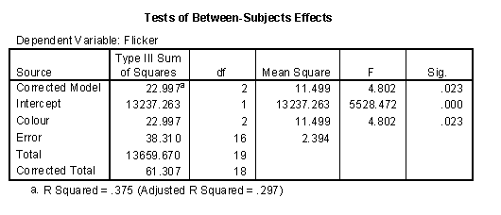

To change the overall look of your document, choose new Theme elements on the Page Layout tab. To change the looks available in the Quick Style gallery, use the Change Current Quick Style Set command. Both the Themes gallery and the Quick Styles gallery provide reset commands so that you can always restore the look of your document to the original contained in your current template.

## Sources of Particulate Matter

### Motor Vehicles

### Industry / Power Plants

### Open Burning / Trans-Boundary

### Characteristics of Particulate Matter

### Effect of Pm10 on Humans

### Weather Influence

## Wind Speed

## Temperature and Sunlight

## Relative Humidity

## Regression Models

### Multiple Linear Regressions

### Robust Regression

### Quantile Regression

## Hybrid Model

### Principal Component Analysis

## Conclusion

# METHODOLOGY

## Introduction

## Study Area

## Monitoring Record Acquisitions

## Parameters Selection

## Monitoring Record Screening

## Descriptive Statistics

### Box and Whisker Plot

### One Way Analyses of Variance

## Monitoring Record Management

## Regression Models

### Multiple Linear Regression Models

### Robust Regression Models

### Quantile Regression Models

## Artificial Neural Network Models

### Feedforward Models

### General Regression Neural Network

## Principal Component Analysis

# RESULTS AND FINDINGS

## Introduction

## Characteristic of Monitoring Record

### Descriptive Statistics

### Box and Whisker Plot

### One Way Analyses of Variance (ANOVA)

## Regression Models

### Multiple Linear Regression Model

### Robust Regression Models

### Quantile Regression Models

## Artificial Neural Network Model

### Feedforward Backpropagation Models

### General Regression Neural Network Models

## Application of Hybrid Models

### Principal Component Analysis

### Principal Component Analysis and Multiple Linear Regressions

### Principal Component Analysis and Robust Regression

## Verification of Models

## Determining the Most Suitable Model

## Developing a New Predictive Tool for Future PM10

## Concentrations Prediction in Malaysia

# DISCUSSION

## Introduction

## Regression Models

## Artificial Neural Network Models

## Hybrid Models

## The Most Suitable Model

# SUMMARY AND CONCLUSIONS

## Conclusion

=VVVVV

## Limitation and Future Work

REFERENCES

APPENDICES

APPENDIX A

APPENDIX B

BIODATA OF STUDENT

LIST OF PUBLICATIONS